
National School of Business Management
BSc in Management Information Systems (Special) Degree
BSc in CS/SE/BIT
Model Paper/ most suitable answer
Web Based Application Development

Time: 03.00Hrs
Answer All Questions.
PART A
Underline the most suitable answer (2 marks x10 = 20 marks)
1.Wich entity do you use to display Unicode character >on a webpage?
a) &ft;
b) &lt;
c) &gt;
2. Who is making the Web standards?
a) Google
b) The World Wide Web Consortium
c) Microsoft
3. Which of the following will display a Username field in a form?
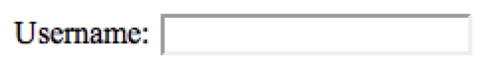
a) <input =" Username " name=" uname " /> b) <input type="Username" name="text" />
c) Username: <input type="text" id="name">

4. What are the HTML tags for a bulleted list?
a) <br> <li>
b) <hr> <ul>
c) <ul> <li>

5. What is the correct HTML for insert a graphical image? Image given as student.jpg in location images
a) <img ="student.jpg" />
b) <input type img= student.jpg>
c) <img src="images/student.jpg" />

6. What is the correct HTML for making a drop-down list?
a) <input type="list" />
b) <input type="dropdown" />
c) < select>

7. What is the correct HTML for making a hyperlink?
a) <a href = "http://www.abc.com" > abc company</a>
b) <a url = "http://www.abc.com" > abc company</a>
c) <a> name = abc company “http://www.abc.com" > </a>
8. What is correct way to write a CSS color values?
a) p {background-color: black};
b) p {bg-color: black };
c) p {background-color: black;}
d) p <background-color>:{ black };
9. Which of the following statements is TRUE for PHP
a) PHP is client-side scripting language
b) PHP scripts are executed on the server
c) PHP files can contain text, HTML, CSS, JavaScript, and PHP
d) all of the above are true

10. What is the correct PHP Pre-increment?

- ++X
- X+
- X++
- ++$X
Answers
- c
- b
- c
- c
- c
- c
- a
- c
- d
- d

PART B
Question 1
- Write a JavaScript program to display following. (4 marks)
Sample Output: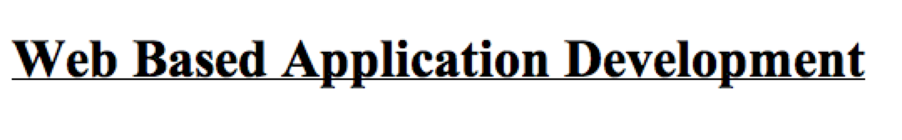
<script language="javascript" type="text/javascript">
document.write("<h1><u>Web Based Application Development</u></h1>");
</script>

- Write a JavaScript program to pops up prompt box. (4 marks)


<script language="javascript" type="text/javascript">
prompt("enter your university name?");
</script>
- Write a JavaScript program to find the square root of 25 (4 marks)
<script>
var a = Math.sqrt(25);
document.getElementById("demo").innerHTML = a;
</script>

- Write a JavaScript program to calculate perimeter of the circle (radius = 10) (4 marks)

<html><body>
<script language="javascript" type="text/javascript">
var r=10;
var p=Math.PI;
var peri=2*p*r;
document.write("The perimeter of the circle =" +peri);
</script>
</body></html>
- The table “StudentR” in the database “StudentMemo” consists of the fields Student ID, Student Name and Programme. Assuming that the database and the table have already been created using MySQL, write a PHP page to insert the following record to the “StudentR” table.

Student ID | Student Name | Programme
PLY0001 | Kamal | SE
UCD0002 | Ajith | CS
db.php is given bellow
<?php
$mysql_hostname = "localhost";
$mysql_user = "root";
$mysql_password = "";
$mysql_database = " StudentMemo ";
$bd = mysql_connect($mysql_hostname, $mysql_user, $mysql_password)
or die("Opps some thing went wrong");
mysql_select_db($mysql_database, $bd) or die("Opps some thing went wrong");
?>
<?php
include("db.php");
$studentid=$_POST[' Student ID '];
$ Student Name =$_POST[' Student Name '];
$ Programme =$_POST[' Programme '];
mysql_query("INSERT INTO StudentR (StudentID, StudentName, Programme ) VALUES ('$ Student ID ', '$Student Name ','$Programme ')");
?>

(20 marks)

Question 2
The web site that support to booking playground and hut
a) Create an HTML page to show following: (8 marks)
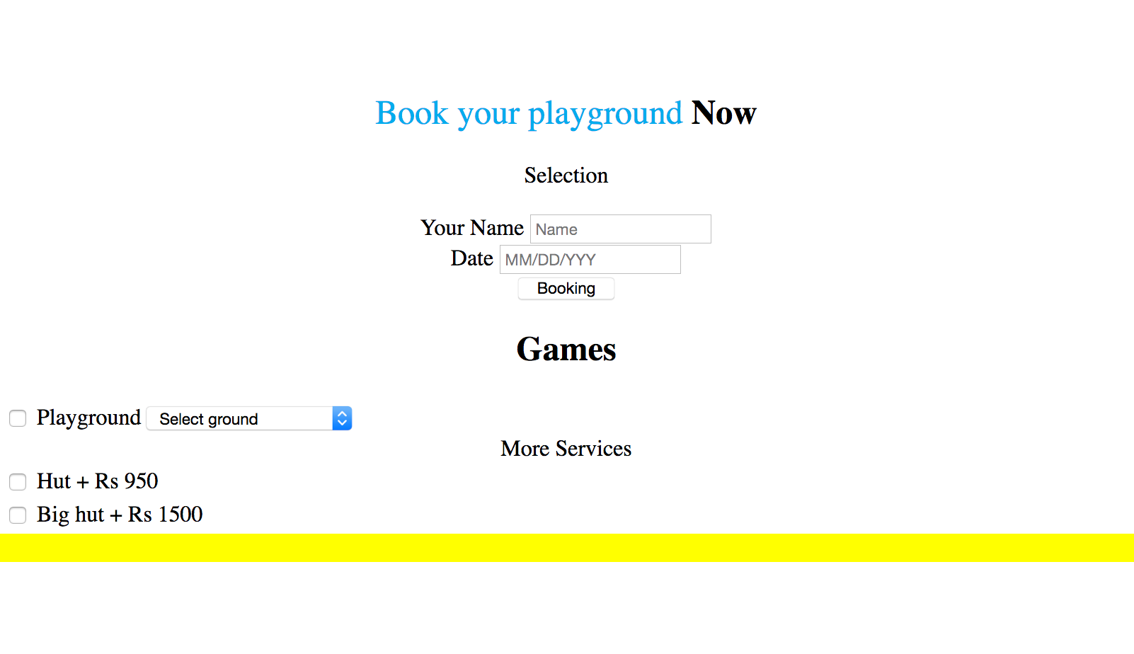

<!doctype html>
<html>
<head>
<meta charset="UTF-8">
<link rel="stylesheet" type="text/css" href="webtest.css">
</style><script language="JavaScript" src="jsvalidation1708web.js"
type="text/javascript" ></script>
<title>Untitled Document</title>
</head>

<body>
<section class="contact bootstrap-iso" id="contact">
<div class="container">
<div class="row">
<h2><strong> Book your playground</strong> Now</h2>
<p>Selection</p>
<div class="about-jyll-content">
<div class="col-lg-8 col-lg-offset-2 col-md-6 col-sm-6 col-xs-12">
<form action="" id="sneakForm" name="sneakForm" method="post" role="form" accept-charset="utf-8">

<div class="row">
<div class="form-group col-lg-6">
<label class="control-label c" for="name">Your Name</label>
<input class="form-control" id="name" name="time" placeholder="Name" type="text"/>
</div>

</div>

<div class="row">
<div class="form-group col-lg-6">
<label class="control-label c" for="date">Date</label>
<input class="form-control" id="date" name="date" placeholder="MM/DD/YYY" type="text"/>
</div>

<button type="button" class="btn btn-default btn-outline" data-toggle="modal" data-target="#myModal">Booking</button>

<div class="modal fade" id="myModal" tabindex="-1" role="dialog" aria-labelledby="myModalLabel" aria-hidden="true">
<div class="modal-dialog">
<div class="modal-content">
<div class="modal-header">
<h4 class="js-title-step"></h4>
</div>
<div class="modal-body">

<div class="row hide" data-step="1" data-title="Choose Your game">
<div class="well"><h2>Games</h2>
</div>
<table class="table table-primary">
<tbody>
<tr>
<td>
<input type="checkbox" name="ground" id="ground" onclick="calculateTotal()"> Playground
</td>

<td>
<select id="Playground" name="Playground" onchange="calculateTotal()">
<option value="none">Select ground</option>
<option value="Cricket-75m">Cricket: Rs 1000</option>
<option value="Football-100m">Football: Rs 2000</option>
<option value="Rugby-150m">Rugby: Rs 3000</option>
<option value="Field-Hockey">Field hockey: Rs 3500</option>

</select>
</td>

</tr>

</tbody>
</table>

<div class="well">More Services</div>
<div class="col-lg-12">
<table class="table table-secondary">
<tbody>

<tr>
<td>
<input id="hut-sunset" type="checkbox" name="hut-sunset" value="950" onclick="calculateTotal()"> Hut + Rs 950 <br>
</td>
</tr>
<tr>
<td>
<input id="big-hut" type="checkbox" name="big-hut" value="1500" onclick="calculateTotal()"> Big hut + Rs 1500 <br>

</td>
</tr>

</tbody>
</table>
</div>
</div>
<div id="totalPrice" style="display: block"></div>
</div>

</div>
</div>
</div>

</form>
</div>
</div>
</div>
</div>
</section>

</body>
</html>
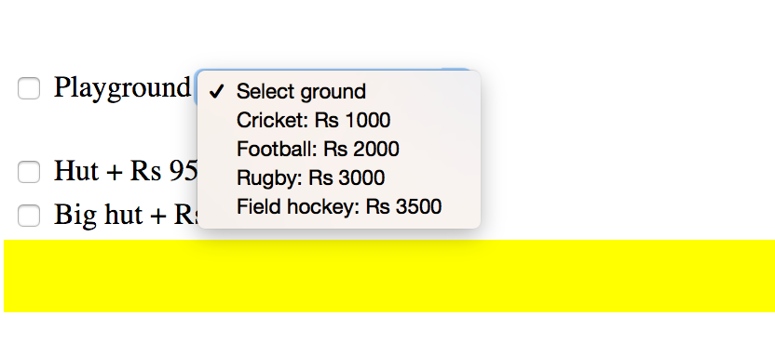

- Create an CCS file to show above Output.(4 marks)
@charset "UTF-8";
/* CSS Document */

#contact{
padding: 4rem 0;
overflow: hidden;
text-align: center;
}
#contact h2 strong{
color: #00aced ;
font-weight: 300 ;
}

/* Additional Services*/

#myModal td{
text-align: left;

}

#myModal .well h2{
text-align: center;
}

#myModal div#totalPrice{
padding:10px;
font-weight:bold;
background-color:#ff0;
}

- Create JavaScript file to validate Name and date fields. (4marks)
<script language="javascript" type="text/javascript">
function validateform()
{
if(document.form.name.value.length == 0)
{
alert("Please enter name");
return;
}
if(document.form.date.value.length ==0)
{
alert("Please enter date");
return;
}
}
</script>

- Create JavaScript file to calculate to Total price (4marks)

var Playground = [];

Playground["none"]=0;
Playground["Cricket-75m"]=1000;
Playground["Football-100m"]=2000;
Playground["Rugby-150m"]=3000;
Playground["Field-Hockey"]=3500;

//This function finds the ground price based on the
//drop down selection (select option tags)

function getgroundPrice() {

var groundSelect = document.getElementById('Playground');

return parseInt(Playground[groundSelect.value]);
}

function gethutPrice() {
var hut = document.getElementById('hut-sunset');
if(hut.checked){
return(950);
} else {
return(0);
}
}

function getbhutPrice() {
var bhut = document.getElementById('big-hut');
if(bhut.checked){
return(1500);
} else {
return(0);
}
}

function calculateTotal(){

//Here we get the total price by calling our function
//Each function returns a number so by calling them we add the values they return together

var total = getgroundPrice() + gethutPrice() + getbhutPrice();

var totalEl = document.getElementById('totalPrice');

document.getElementById('totalPrice').innerHTML = "Your Total is: " + total;
totalEl.style.display = 'block';
}

function hideTotal(){

var totalEl = document.getElementById('totalPrice');
totalEl.style.display = 'none';
}

(20 marks)

*** End of paper***

